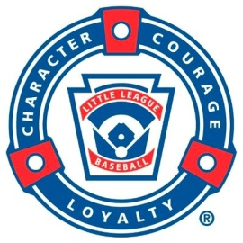

PARENT CODE OF CONDUCT
I hereby pledge that our family will support our baseball team by adhering to the Parent Code of Conduct as stated below:

- We will let the coach be the coach and will respect the coach’s decisions.
- We will show interest, enthusiasm and support for all children on the team.
- We will provide only supportive comments to coaches and players of both teams. We will avoid any derogatory comments. If we have concerns to bring to the coach’s attention, we will apply the “24 Hr. Rule” before having a respectful, private conversation.
- We will not criticize or question the umpire’s calls. We will let the umpires be umpires.
- We will not coach our son or daughter during the game.
- We will avoid the use of alcohol and tobacco products at practices or games or come having drunk too much.
- We will remain in the spectator area and we will be in control of our emotions.
- We will help when asked by umpires or coaches
- Pets are not allowed on YCLL fields.

_______________________________ _________________________
Signature Date

